1 data definition, 2 functions

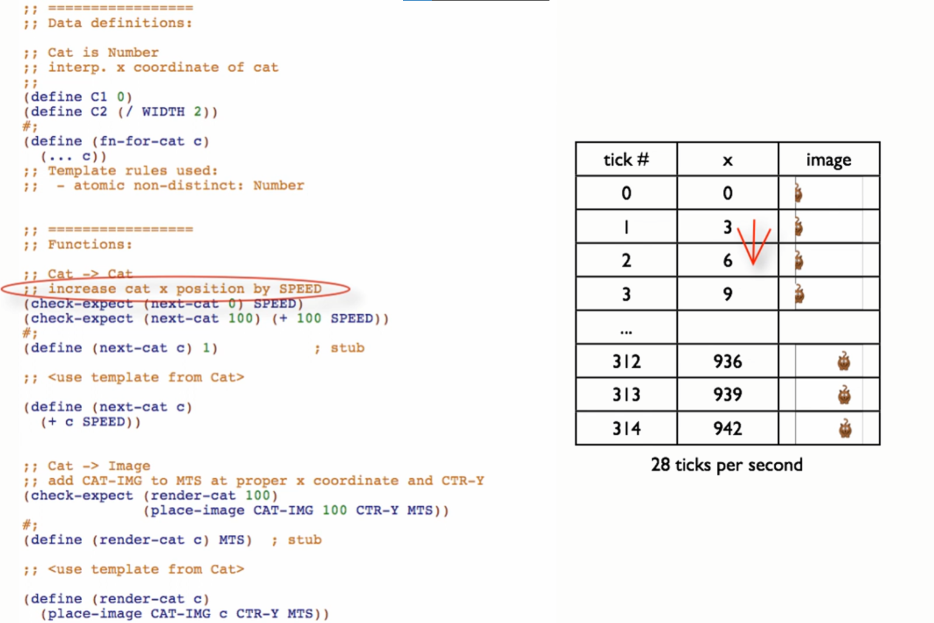

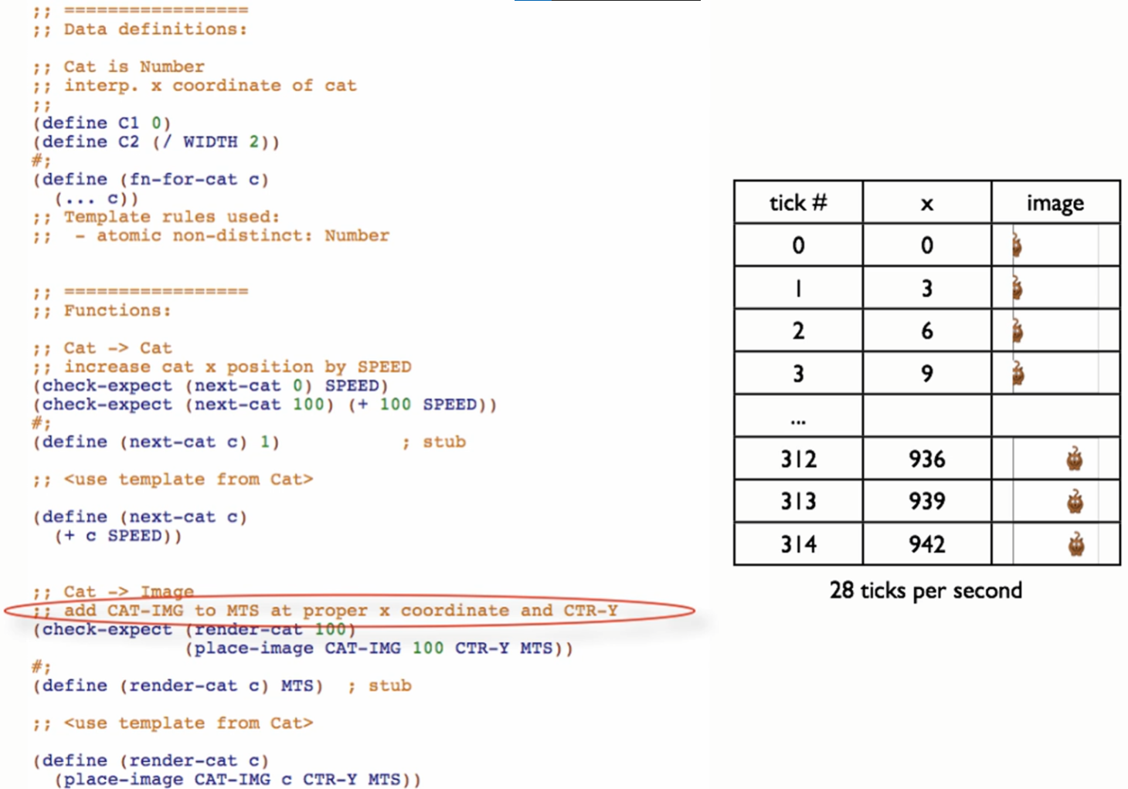

Let’s see how these 2 functions can dance together

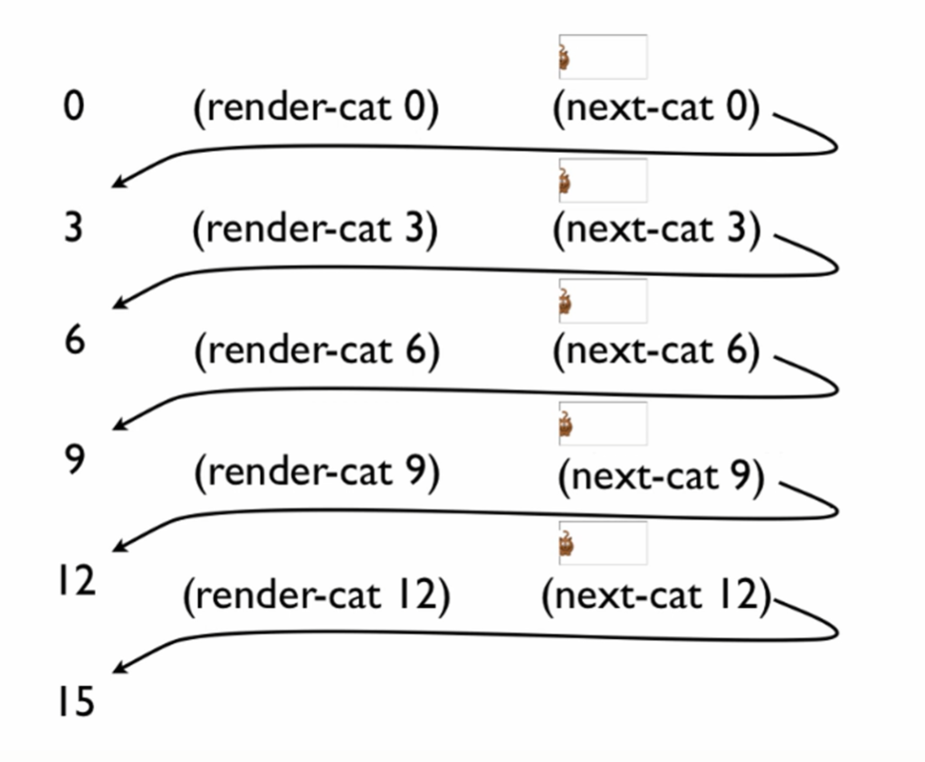

Wiring these 2 functions:

* `big-bang` expression

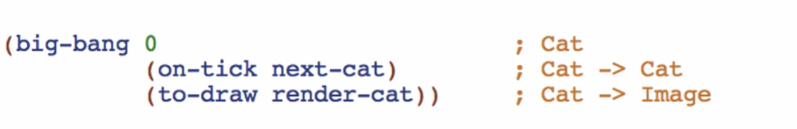

(big-bang [initial state] […options])

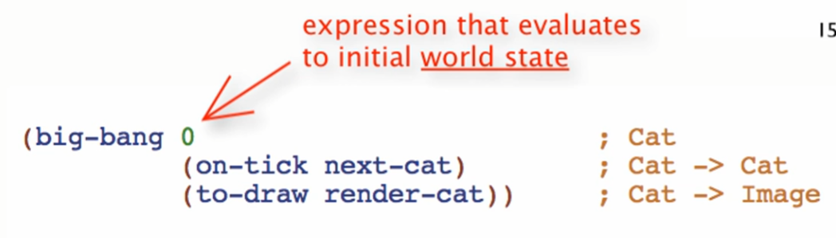

(on-tick next-cat)

* Each time the clock-ticks, call `next-cat` function with the current state of the world to get to the **next** world state
* This is responsible for the increment/decrement of the state of the world

(to-draw render-cat)

* Each time the clock-ticks, call `render-cat` function with the current state of the world to draw the **current** world state

big-bang

* Polymorphic
  + Can work for any type of world state

Better:

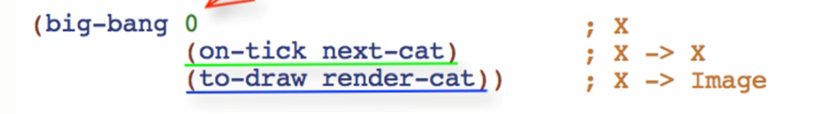

Note:

